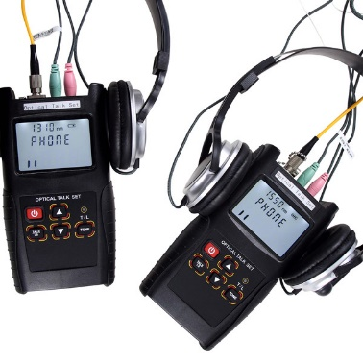
Optical Talk Set S601
S601 is one intelligent and efficient instrument that combines in one set the functions of both a digital optical phone and a stabilized light source.
It is widely used in operations of installation, optical testing, maintenance and fiber attenuation value testing in data network, CATV and telecommunication network.
It can carry out full-duplex communication with high quality connection and not be affected by distance.
With comfortable hand feelings, and nice outside looking, the user can easily operate on this optical tester.
Features
Full-duplex digital communication with high quality conversation connection and low background noise.
Together with optical clip-on coupler, enables on line communications available
Combining functions of both a digital optical phone call and a stabilized light source.
Large LCD display with backlight
Low battery power indication
Laser source have the modulation of 270Hz, 330Hz, 1KHz, 2KHz.
Specifications
Type | S601
Wavelength(nm) | 1310(A)/1550(B)
Fiber type | SM
Dynamic range(dB) | 45
Distance(km) | 120
Laser Device type | FP-LD
Output adjustment(dB) | 1
Output power(dBm) | -5～-15
Output stability(dB,30min,20℃) ¹ | <0.05
Modulation | CW, 270Hz, 330Hz, 1KHz, 2KHz
Connector type | FC/PC
Battery | 3*AA,1.5V
Battery operation time(h) ² | 30(Talk set function),50(laser source function)
Work temperature (℃) | -10～+60
Storage temperature (℃) | -25～+70
Dimension(mm) | 161×90×44
Weight(g) | 225
Remark:
- Laser source in modulation, may influence the stability of the output power, this is the normal case.
- The battery operation time is defined under the back light off, if the backlight on, the operation time may shorter.

