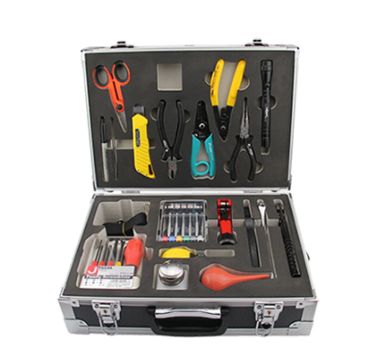
Fiber Optic Tool Kit S22
The S22 tool kits is very suitable for optical fiber fusion splicing. It includes all the most frequently needful tools and supplies required for cable sheath removal and fusion splicing.
Specifications
NO. | ITEM | NO. | ITEM
1 | Fiber optic stripper CFS-2 | 12 | Screwdriver S/D (-)5×100mm
2 | KEVLAR Scissor | 13 | Screwdriver S/D (+) #1×100mm
3 | Longitudinal Buffer Tube Slitter | 14 | Screwdriver S/D (-)6×100mm
4 | Steel Wire Rope Cutter | 15 | Screwdriver S/D (+) #2×100mm
5 | Round Cable Cutter | 16 | 4 oz. Bottle of Alcohol
6 | 6Pcs Electronic Screwdriver Set | 17 | Blow Brush
7 | 6'' Lineman's pliers | 18 | Utility knife
8 | 6'' Needle Node Pliers | 19 | 3.5M Tape Measure
9 | 6'' Side Cut Pliers | 20 | Precision tweezers
10 | 8" Adjustable wrench | 21 | Black Marker
11 | LED Flashlight | 22 | Carrying Tool Case(385×275×110mm)

